Government College Of Engineering Karad

(An Autonomous Institute of Government of Maharashtra)
Academic Year 2024-2025

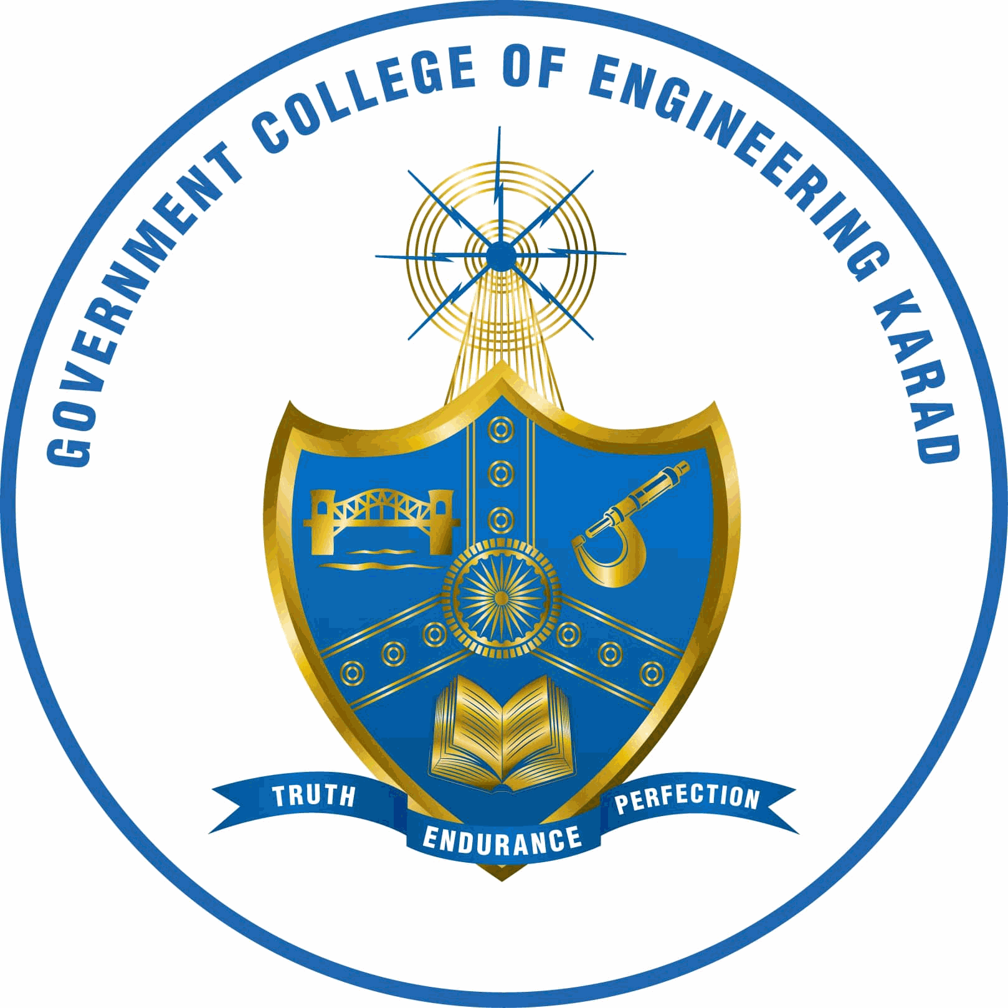

Final Year B. Tech. Information Technology
2025-26
Semester VIII

IT2711: Seminar [Synopsis]

Title of the Seminar : AI Legal Assistant

Sr. | Roll No | Name | Email | Mobile | Sign
1. | 22141229 | Soham Sunil Malvadkar | soham05malvadkar@gmail.com
2. | 22141234 | Sanket Nivas Chopade | sanketchopade2025@gmail.com
3. | 22141236 | Abhijeet Vilas Ganjave | abhijeetganjave04@gmail.com
4. | 22141244 | Akash Anada Khot | akkikhot2309@gmail.com
5. | 22143248 | Sanket NandKumar Adake

Date: Name & Signature Name & Signature
Guide Project Coordinator

